***Team :***

We have decided on a 3-man team composed of the following students : Stan Andrei (3E3), Vasilica Georgiana (3E1), Dumitru Mihai (3E2).

***Game type :***

We’d like to create a top-down 2d shoot-em-up type of game combined with rpg elements (possible elements such as : map exploration, crafting, upgrades, equipment, creature / npc - player dialogue, environment interactions, etc).

***Game concept :***

The concept of the game is simple, dynamiclly modifying the players environment based on progression, having interchangable elements (such as creatures, objects, etc), the players progression is based on continuous rounds of shoot-em-up levels, these interchangable maps being a possible resting point for the player if they so desire. The sprites / design of these maps, creatures, objects and so on will be based on pixel art similar to Undertale, simple and yet efficent clip-art.

***Links to similar concepts :***

* Shoot-em-up games :
  + <https://store.steampowered.com/app/505630/Let_Them_Come/>
  + <https://store.steampowered.com/app/1510460/Chicken_Invaders_Universe/>
* RPG elements and art style :
  + <https://store.steampowered.com/app/599140/Graveyard_Keeper/>
  + <https://store.steampowered.com/app/413150/Stardew_Valley/>
  + <https://store.steampowered.com/app/391540/Undertale/>
  + <https://store.steampowered.com/app/1671210/DELTARUNE/>

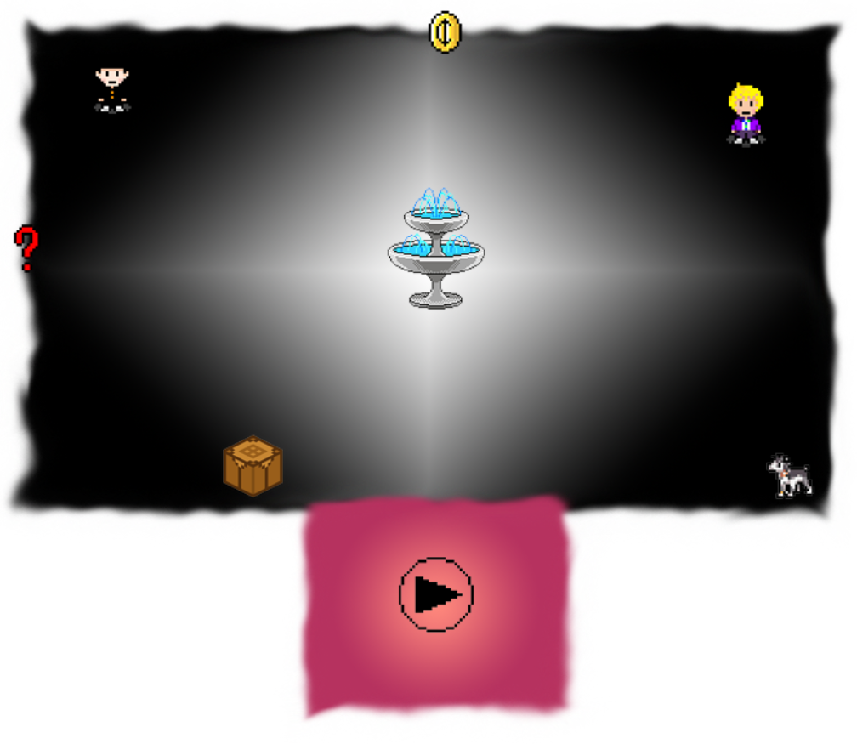

A simple diagram of how the

game would look (map-wise) :

**The turret defense part of the game :**

* You control a turret and the goal is to stop the impending enemy hordes from reaching your position (extra idea : a endless survival level).
* The player controlled turret in the main bunker can be upgraded and there are different weapons that can be chosen. ( Autocannon, Large cannon, flamethrower, mine launcher etc.)

**Extra ideas :**

* The player can also upgrade the bunker with additional firepower like AI controlled machineguns, rifles ,flamethrowers etc.
* The player can build infrastructure on his friendly side ( such as trenches that friendly units can occupy, gun emplacements, mortar squads, anti-air emplacements etc.)
* The enemy can use as cover the craters left behind by you or your emplacements.
* They can also build cover that stops conventional bullets but can be destroyed by your cannons.
* They can build cover that is immune to cannon fire but is vulnerable in other ways.

